Note Eight

* Hypothesis tests and confidence intervals
* 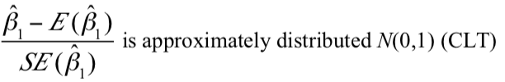
* Since they are not independently distributed
  + Cannot use t test
* Joint hypothesis
  + 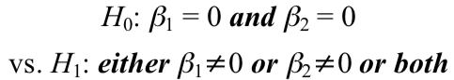
  + Cannot test one at a time
    - The reject probability is different
    - Solution
      * Use a different critical value
      * Use a different test statistic ⇒ **F-test**
* F test
  + 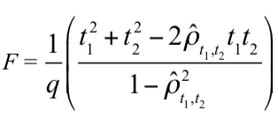
  + Always positive
  + Restrictions → number of coefficients being tested
* Test single restrictions on multiple coefficient
  + 
  + Single restriction but involves two coefficients
  + Solution
    - 1
      * Rearrange the regression
        + 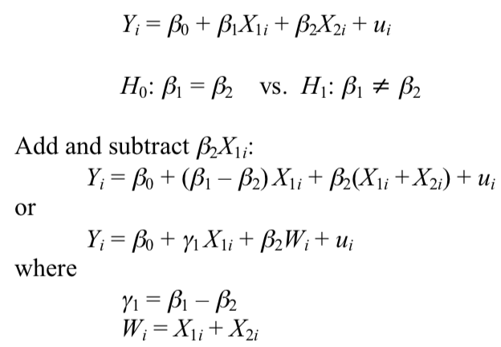
        + Then we can do t-test for the coefficient of X1
    - 2
      * Perform the test directly
        + 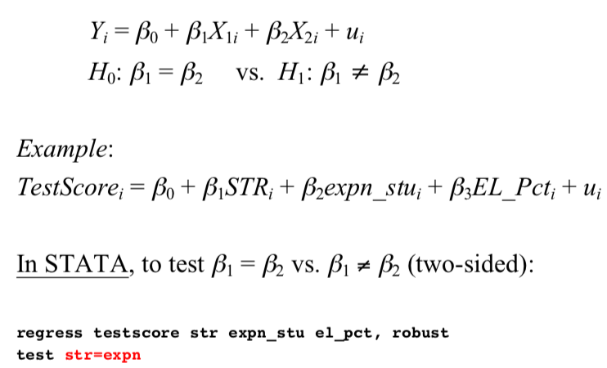
* Omitted variable bias again
  + Must contain a variable “Z” that is both
    - A determinant of Y
    - Correlated with at least one of the regressors
  + If both conditions are met
    - At least one of the coefficient will be biased
* Control variables
  + A variable whose relationship with Y is not the main interest of your study
  + But still include it and hold it constant so that **avoid omitted variable bias**’
  + 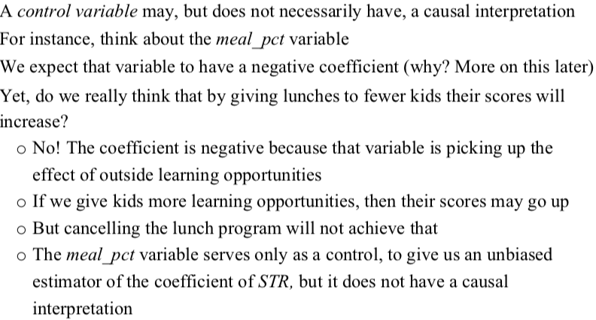
* General approach to variable selection and model specification
  + Specify a “base” and “benchmark” model
  + Specify a range of plausible alternative models
  + **But do not try to max R2**
    - **High R2 means that the regressor explains the variation in Y**
    - **DOES NOT mean that you have eliminated omitted variable bias**
    - **Therefore, does NOT mean that you have an unbiased estimator of a causal effect ß1**
  + **Instead** 
    - **Should test using hypothesis testing**
* Summary

